

**ENGLISH FINAL EXAM**

|  |  |  |  |  |  |  |
| --- | --- | --- | --- | --- | --- | --- |
| **Apellidos y Nombres:** | **VEGA ORTIZ DAVID KENSHIN** |  | **Sección:** |  |  | **Nota:** |
| **Carrera:** | **DESARROLLO DE SISTEMAS E INFORMACION** |  | **Fecha:** | **19/12/2023** |  |
| **Nombre del Docente** | **Lic. Lizsette S. Santoyo Armas** |  |  |  |  |

***WHAT ARE YOU WEARING?***

1. Look at the picture and write the name of the clothes: (4p)

|  |  |  |  |
| --- | --- | --- | --- |
| Q3201903-BKW-1.jpg  CAP | How to Draw A Dress Design  DRESS | how-to-draw-a-sweater-step-11-4  SWEATER | Imagen relacionada  SHORTS |

1. Write two sentences about your abilities: (2p)
2. My skill in memorization enables me to retain large amounts of data and information effortlessly
3. I'm really good at math. I can solve hard problems easily and accurately.

***SIMPLE PAST TENSE: REGULAR AND IRREGULAR VERBS***

1. Write the correct form of the verb in past tense: (4p)
2. We **did not play** (not play) tennis last Monday.
3. They **had** (have) breakfast at 6:30 a.m. yesterday.
4. Juan **cooked** (cook) yesterday afternoon.
5. Fernando **did not cook** (not cook) last Tuesday.
6. 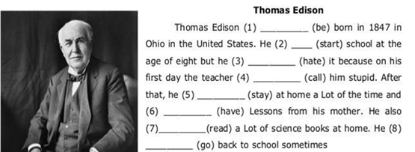Complete with the correct form of the verb in past tense: (4p)

went

read

had

stayed

called

hated

started

was

1. Write two affirmative, negative and yes/no questions in past tense: (6p)

* He traveled to Paris last summer.
* She read the entire book in one sitting.
* They didn't go to the party last night.
* I didn't eat breakfast this morning.
* Did you visit the beach last weekend?
* Did they enjoy the movie?